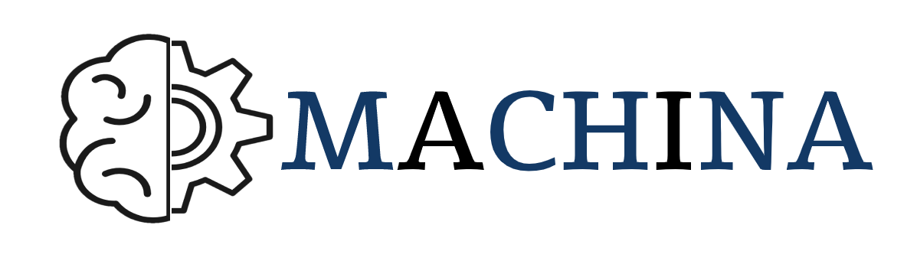
MACHINA – MACHINE LEARNING SKILLS FOR ICT PROFESSIONALS

VET Integration Guidelines

Project details
Project acronym: MACHINA
Project name: MACHINA – MACHINE LEARNING SKILLS FOR ICT PROFESSIONALS
Project code: 2020-1-FR01-KA202-080386
Document Information
Document ID name: | MACHINA_O2-T4_VET integration guidelines_2021-11-20
Document title: 2020-1-FR01-KA202-080386
Output Type: Intellectual Output
Date of Delivery: /11/2021
Activity type: Report
Activity leader: L3S
Dissemination level: Public
Document History
Versions | Date | Changes | Type of change | Delivered by
Version 1.0 | 20/11/2021 | Initial document |  | L3S

Disclaimer
The European Commission support for the production of this publication does not constitute an endorsement of the contents, which reflects the views only of the authors, and the Commission cannot be held responsible for any use, which may be made of the information contained therein.
The project resources contained herein are publicly available under the Creative Commons license 4.0 B.Y.

Table of contents
1. INTRODUCTION 5
1.1 MACHINA project description 5
1.2 The Goal of the VET Report 5
2. Learning units integration methodology 7
2.1 Phase 1: Prepare 7
2.2 Phase 2: Design 7
2.3 Phase 3: Run & Evaluate 8
2.4 Phase 4: Optimize & Run 9
2.5 Methodology for developing additional units 9
3. Referencing National Qualifications Levels to the EQF 10
3.1 What is referencing to the EQF 10
3.2 How referencing is applied in MACHINA 10
3.3 French Qualification Framework Reference 10
3.4 German Qualification Framework Reference 13
3.5 Italian Qualification Framework Reference 16
3.6 Romanian Qualification Framework Reference 18
3.7 Greek Qualification Framework Reference 20
4. Example of integrating learning units 22
4.1 Integration Phase 1: Prepare 23
4.2 Integration Phase 2: Design 24
5. MACHINA Project Certification 27
6. References 28

ABBREVIATIONS
MACHINA CONSORTIUM
UCBL | UNIVERSITE LYON 1 CLAUDE BERNARD
L3S | GOTTFRIED WILHELM LEIBNIZ UNIVERSITAET HANNOVER
EXELIA | EXELIA E.E
ACADEMY | GEEKS ACADEMY EUROPE SRL
ANC | AUTORITATEA NATIONALA PENTRU CALIFICARI-ANC
ML | MACHINE LEARNING
EU | EUROPEAN UNION
VET | VOCATIONAL EDUCATION AND TRAINING
ICT | INFORMATION AND COMMUNICATIONS TECHNOLOGY
EQF | EUROPEAN QUALIFICATIONS FRAMEWORK
WBL | WORK-BASED LEARNING
ISCED | INTERNATIONAL STANDARD CLASSIFICATION OF EDUCATION

1. INTRODUCTION

1.1 MACHINA project description
Machine Learning (ML) is a subset of Artificial Intelligence (AI) that has gained substantial prominence in diverse economic & social realities, has become the basis for a series of technological developments such as automated translation systems, medical image analysis, and virtual assistants. ML was born from pattern recognition but has evolved to refer to the use of data & learning algorithms to produce models, predict outcomes, and make decisions with minimum human intervention. The fast-paced expansion of ML, especially in data-driven industries (e.g. banking, retail), is rapidly pushing up the demand for skilled ICT workers in the EU. While the demand for ML expert workers is particularly high, the supply is severely lagging.
MACHINA project aims to enhance Vocational Education and Training for ICT professionals in the field of Machine learning.
MACHINA is an Erasmus KA2 project, which aims to tackle this ML skill deficit by increasing the relevance of Continuing & Initial VET provision in the sector, to assure that the existing & future ICT workforce will have the ML specific competences & transversal skills required to respond to modern workplace requirements and succeed in a competitive, fast-growing field. The project will also make available transnational educational materials in the form of OERs, to ensure wide adoption and support VET provision in a cost-effective, flexible way.

1.2 The Goal of the VET Report
The rapid development of the field of artificial intelligence, and machine learning in particular, is leading to a need to refresh, deepen and acquire new knowledge by ICT professionals in this field.
The challenge today is to create an updated VET system for ICT workers to bring their competencies and skills in line with market needs in machine learning, as well as to facilitate the development of professional skills and to facilitate employment and mobility within the IT sector.
To meet the EU training needs of today's ICT professionals in terms of practicality, flexibility, cost-effectiveness, and accessibility, open educational resources should be developed to provide easy and free access to the online learning materials, which facilitating self-learning at a personal pace at any convenient time and place for such a professional.
The curriculum framework and expected learning outcomes indicate what teachers and students should know and do. The curriculum describes what, why, how, and how well learners should learn systematically and purposefully.
To improve the quality of education, a special effort must be made to reconcile the intended and subsequently implemented curriculum as well as the achieved curriculum (what learners actually learn).
The expected learning outcomes define the body of information, knowledge, skills, and competencies that each learner will acquire upon completing the curriculum. In several countries, curricula are largely determined at national levels, while in other education systems, curricula are more a matter of local decision-making, guided by a system of learning standards.
The primary outcome of the MACHINA project will be the development of training units and open educational resources for ICT professional development in machine learning. Therefore, it is important to provide VET providers with practical guidance to facilitate the integration of the developed training modules into VET curriculum for ICT specialists.
This document will provide guidelines and instructions to VET providers on how to implement learning units, assign the most appropriate learning outcomes according to the National Qualifications Framework (NQF), and develop exercises and assessment methodologies for current training programs and curricula.
This report is based on the information provided by partners about the specific features of the VET systems in their countries. Knowing these details is the only way to develop a procedure that VET providers could subsequently use to incorporate MACHINA project training units.

2. Learning units integration methodology
Dividing the integration methodology into four phases will allow VET providers to go through a sequence of processes in each phase to ensure that their organization gets the best possible results from using the learning units of the MACHINA project.

2.1 Phase 1: Prepare
- Identify the team that will be responsible for the integration process. Interaction with colleagues will avoid the risk of adopting only the trainer's perspective and ensure that the broadest possible perspective is adopted.
- To ensure good results from the use of MACHINA project training units, it must be determined whether the training process is successful.
- Select the curriculum most appropriate to integrate. Choose a training program, which is best suited to the integration of MACHINA training units and offers added value to organizations.
- Obtain feedback from as many stakeholders as possible.
- Identify the revised learning outcomes of the curriculum based on the MACHINA learning units being integrated.

2.2 Phase 2: Design
- Identify the main constraints to course design. Consult with the VET provider's program management and identify the constraints related to:
  - Time available in the organization’s program
  - Human resources available to develop, implement and deliver the new training program
  - Time before the release of the new training program
  - Other conditions to be considered.
- Identify the potential learning units to be replaced by MACHINA units. If the course duration cannot be extended and one or more units from the existing curriculum need to be replaced by new units, break down the existing curriculum into units and, after examining the possible overlaps between them, decide which of the existing units will be replaced.
- Check prerequisites consistency of the selected MACHINA learning unit to be integrated. Check whether the knowledge and experience required by the student for the course are covered by the prerequisite requirements of the existing curriculum.
- Determine the sequence of the learning units based on the prerequisites as well as the flow of teaching that corresponds to the course objectives.
- Calculate the total duration of the curriculum, summarizing contact hours, practical exercises, independent work, and assessment of new and existing units of study.
- Assign a national qualification to the training program based on the methodology described in section 3.
- Train (if necessary) the course instructors. Assuming that they are experienced/appropriately qualified.
- In cooperation with the teaching staff, integrate the existing training material with the MACHINA open educational resources.
- The choice of approach and format for the existing curriculum depends on the overall strategy and general practice of the VET provider.
- Integrate assessment materials. Modify existing assessment procedures, either by using the assessment materials proposed by MACHINA or by developing new assessment materials or both, to create a unified methodology that assesses learning outcomes as a whole.

2.3 Phase 3: Run & Evaluate
- Run a pilot course. The VET provider forms a group of students (to be determined later) who meet the preliminary requirements. Alternatively, the training can take on students' and teachers' roles and deliver a short course using the new learning units in conjunction with the training and assessment equipment.
- Evaluate the pilot course and the learning process based on feedback from teachers and students. Evaluation tools include face-to-face interviews and group discussions focusing on the scope of the learning objectives and potential improvements.

2.4 Phase 4: Optimize & Run
- Make changes to the curriculum structure content and materials based on the evaluation process and optimize the curriculum, which will help to achieve the best possible learning objectives.
- Run the new course. Implement all necessary promotional activities and launch the course.

2.5 Methodology for developing additional units
If an institution needs to develop new, complementary modules for digital asset management training, the entire methodology followed by the MACHINA partnership to develop the MACHINA training modules is available in the Resources and Outputs section of the MACHINA project on the official project website. The methodology includes reports that describe the steps taken by the MACHINA partners and can also be used when expanding MACHINA's work to meet the needs of different/specialized target groups:
- Identification of search tools for collecting data from different partners
- Analyzing data and reporting on learning outcomes
- Learning outcomes by grouping learning unit;
- Specification of learning units.

3. Referencing National Qualifications Levels to the EQF

3.1 What is referencing to the EQF
Referencing is the process by which the relationship between national qualifications levels, usually defined in terms of the national qualifications framework, and EQF levels are established. In this process, the national authorities responsible for qualifications systems, in cooperation with the stakeholders responsible for the development and use of qualifications, define the correspondence between the national qualifications framework and the eight EQF levels.

3.2 How referencing is applied in MACHINA
Based on the European Framework descriptors of qualifications and learning outcomes in terms of competencies, skills, and knowledge, all MACHINA learning units have been assigned the highest level that VET qualifications can achieve, which is EQF-5. More specifically, the QE 5 descriptors for knowledge, skills, and competencies define the following:
Knowledge: Comprehensive, specialised, factual and theoretical knowledge within a field of work or study and an awareness of the boundaries of that knowledge.
Skills: A comprehensive range of cognitive and practical skills required to develop creative solutions to abstract problems.
Competencies: Exercise management and supervision in contexts of work or study activities where there is unpredictable change; review and develop performance of self and others.
MACHINA partners have conducted research and consultation on how EQF-5 can be transferred to the NQF of each partner country so that VET providers in each country (Greece, Romania, Germany, Italy, and France) could assign the most appropriate level for the new curriculum.

3.3 French Qualification Framework Reference
France has an NQF based on a five-level structure with a strong labor market orientation, as it does not include general education. It covers vocationally and professionally oriented qualifications, including all higher education qualifications with a vocational and professional orientation and purpose.
The RNCP (Répertoire National des Certifications Professionnelles) includes three main types of qualifications:
- Qualifications awarded by the French ministries in agreement with the social partners,
- Qualifications awarded by training providers, chambers, and ministries, but in the absence of an advisory committee,
- Qualifications awarded by the social partners under their own responsibility.
In France, the following levels are included in education and training:
- Pre-primary education (ISCED level 0).
- Primary (compulsory) education for 6–11-year-old (ISCED level 1);
- Lower secondary education for students aged 12-16 years in colleges (ISCED level 2)
- Upper secondary education for students aged 16-18 (ISCED level 3).
- Tertiary (ISCED level 5) and higher education (ISCED levels 6, 7 and 8).
Pre-school education is optional, but in practice, all children between the ages of three and six attend it.
In France, schooling is compulsory from age six to sixteen and children have the right to start school at age two and a half. Secondary education starts with 'collège' (lower secondary education), at the age of twelve, and they attend classes for four years.
Students then have the option of choosing between two options: vocational schools (Lycée professionnel) and general secondary schools. When enrolling in vocational schools, students can choose between two different types of qualifications:
- EQF-3 certification (two-year program named CAP), which combines the general upper secondary school and vocational classes: students normally practice in school workshops and in companies, taking an internship which can last from 12 to 16 weeks, depending on the specialty.
- EQF-4 certification (a three-year course called Bac professionnel), which includes general education classes as well as vocational classes and work placements (the statutory number of weeks during the course is 22), and a project undertaken by the student.
At the end of the two-year course, students receive a vocational certificate, which does not allow them to continue their studies in higher education, but they may attend a three-year course to obtain a higher certificate. On the other hand, students with a fourth level certificate can access higher education. Students can also enrol on a two-year dual degree programme run by the National Education and Apprenticeship Training Authority, which leads to a vocational qualification (EQF level 3/4).
As for the EQF Level 5 Vocational Certificates, two-year courses, there are again two possibilities: the Technician Certificate provided by the National Education. This programme is provided by secondary schools. The Bachelor Certificate in Technology, provided by the National Education, and the course provided by the Institute of Technology, part of the universities.
The following vocational education and training system chart for France can be considered
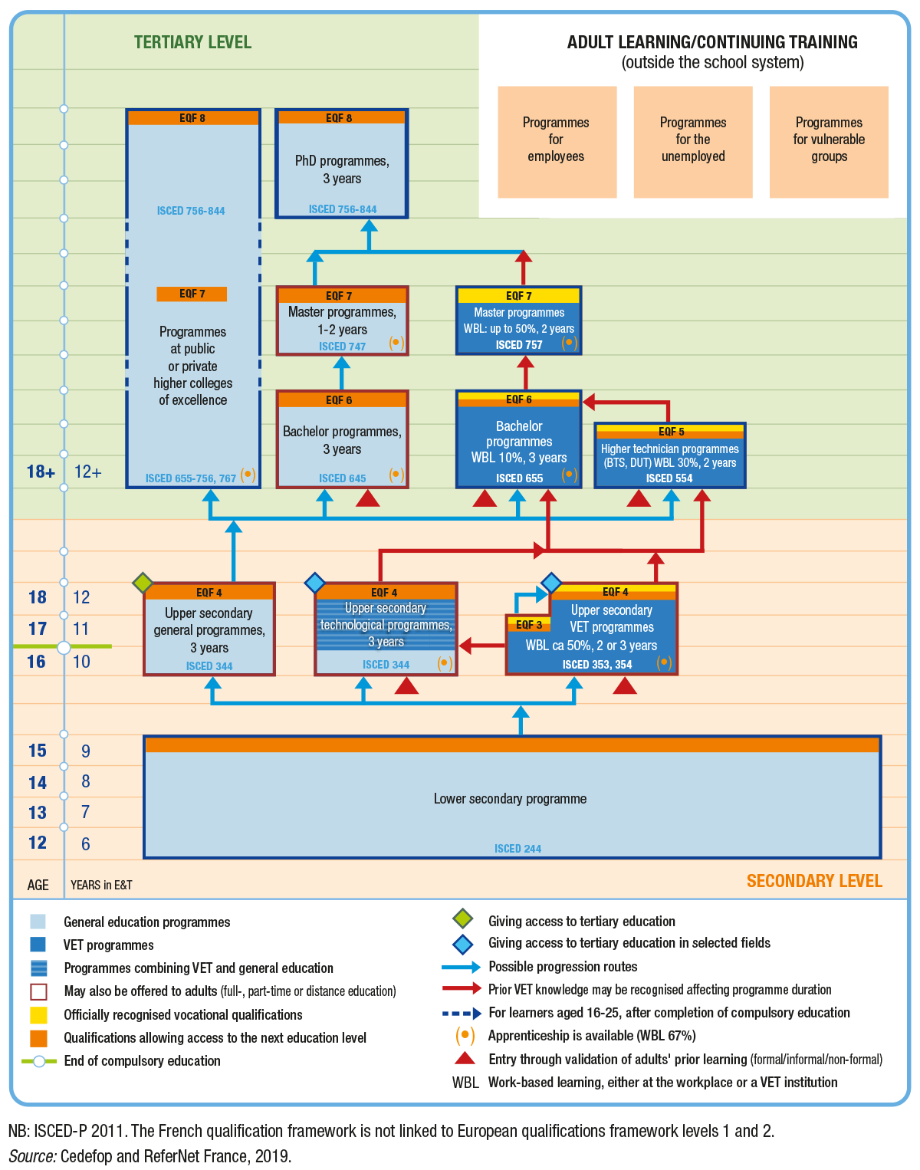

Figure 1: French vocational education and training system chart.
Source: https://www.cedefop.europa.eu/en/tools/vet-in-europe/systems/france-2019.

3.4 German Qualification Framework Reference
German VET is seen as a successful model, mainly based on a dual system (apprenticeships) leading to high quality vocational qualifications.
In addition, close cooperation between employers, trade unions and government in the formation and implementation of VET. Advanced vocational training at the tertiary level (EQF 6-7) leading to master, technician and specialist qualifications is a major factor contributing to the attractiveness of the VET pathway.
National standards and training regulations (curricula for both intramural and school components) ensure the success of dual study programs.
Another feature of the German VET system is its approach to the acquisition of vocational competencies, the so-called 'vocational action competence': this holistic and integrated approach to the acquisition of competencies during VET contrasts with the acquisition of individual skills and competencies based on the 'learning-by-doing' approach of the European Qualifications Framework (EQF).
The education and training system in Germany includes:
- Primary education (ISCED level 1);
- Lower secondary education (ISCED level 2);
- Upper secondary education (ISCED level 3);
- Post-secondary non-tertiary education (ISCED levels 4 and 5)
- Higher education (ISCED levels 6, 7, and 8).
Compulsory full-time education starts at age six and lasts nine years (or 10 years, depending on the federal state). After that, young people who choose not to follow a full-time education program may attend (vocational) school for three years part-time, in parallel with company training. Education is compulsory for all people between 6 and 18 years of age.
Germany is one of the European countries where apprenticeship training is a traditional component of the education system: the apprenticeship program (dual system, with two places of training: 70% in the workplace and 30% at school) is a major component of the VET system. Approximately one in two secondary school graduates chooses vocational education, mostly apprenticeships. Promotion is possible through various regulated VET programs provided at post-secondary and increasingly at tertiary level.
The German VET system includes primary and continuing education; alongside school activities, work-based learning (WBL) plays an important role in most secondary and higher education programs. There are the following options for learning in the VET system, which all include WBL:
- At high school level:
  - Vocationally oriented general vocational programs.
  - School-based VET programs.
  - Apprenticeship programs (including WBL around 75%).
- At post-secondary level:
  - Specialized programs.
- At higher education level:
  - Advanced vocational qualifications and examinations at EQF 5 (certified consultant in certain vocational areas; technician), EQF 6 (master craftsman, specialist), and EQF 7 (management specialist; professional educator, IT professional).
  - Training programs for technicians, specialists, and similar programs.
  - Bachelor's degree programs.
  - Master's degree programs.
In this case, the level of EQF-5 corresponds to the progression of specialized programs, including WBL.
The German vocational education and training system chart is shown below.

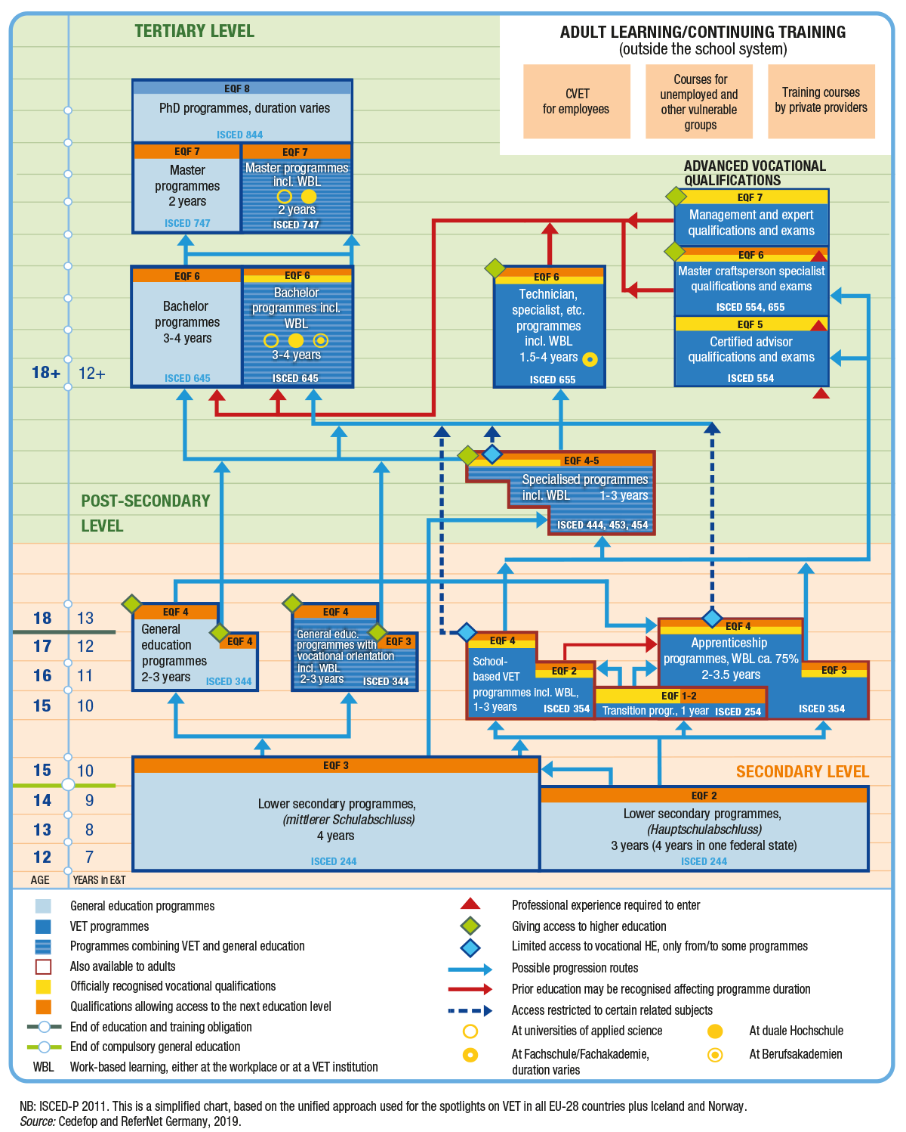
Figure 2: The German vocational education and training system chart.
Source: https://www.cedefop.europa.eu/en/tools/vet-in-europe/systems/germany-2019.

3.5 Italian Qualification Framework Reference
VET in Italy has a number of features. The Italian Ministries of Education and Employment set the rules and general principles, but the regions and autonomous provinces are responsible for VET programs and apprenticeship schemes.
There are three types of apprenticeships in this country, with one type not corresponding to any level of education but leading only to vocational qualifications recognized in the labor market.
The education and training system in Italy includes:
- Pre-school education (ISCED level 0)
- Integrated primary and lower secondary education (ISCED levels 1 and 2), this stage is the first cycle of education
- Higher secondary education (EQF level 4 for general education, also called the second cycle of education);
- Post-secondary education (IFTS - vocational only - EQF level 4)
- Higher education (EQF level 5 for higher technical education programs).
Pre-school education is not compulsory and is provided by education services for children under the age of three.
Compulsory education starts at the age of 6 and continues for 10 years until the age of 16. It covers the entire first education cycle (primary and lower secondary school and two years of upper secondary school).
The final two years of compulsory education can be completed either in upper secondary school or as part of a regional VET system.
The upper secondary school offers both general and vocational (technical and vocational) programs. The study period is five years. At the end of upper secondary school, students who have successfully passed the final examination receive a certificate that gives them access to higher education.
The following institutions offer higher education:
- Universities (including polytechnics);
- Institutes of higher education in the arts, music and dance (Afam)
- Institutes of higher education for language mediators (SSML);
- Institutes of higher technical education (ITS).
Level 5 of EQF corresponds to level 5 of the Italian Qualification Framework, more precisely consisting of a higher technical education diploma. The relevant education/training pathways are Higher Technical Education programs (ITS) and Higher education and research apprenticeship programs.
Studies at higher technical institutes (ITS) are available for students with a secondary school leaving certificate and for students who have taken a four-year regional vocational course followed by an additional year of higher technical education and training (IFTS). Higher technical institutes offer short-cycle bachelor programs in line with the Bologna structure.
A complete view of the education system in Italy is given in the following diagram.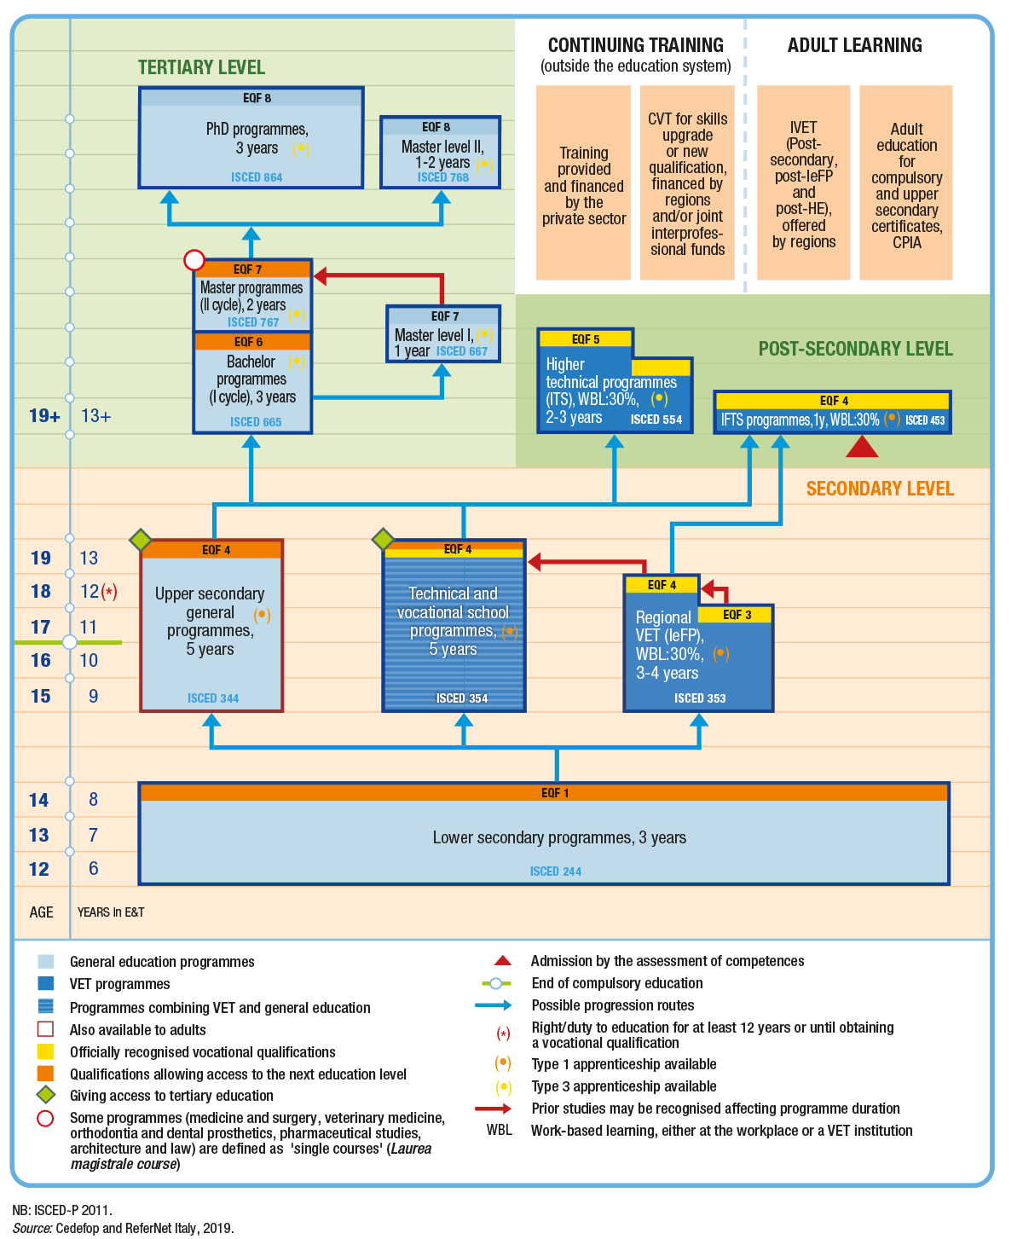
Figure 3: the education system in Italy chart.
Source: https://www.cedefop.europa.eu/en/tools/vet-in-europe/systems/italy-2019

3.6 Romanian Qualification Framework Reference
Since 2013 Romania had its learning-outcomes-based NQF for lifelong learning – the Romanian national qualifications framework (ROQF).
The ROQF comprises eight qualifications levels that can be achieved through education and training and validating learning outcomes in non-formal and informal learning contexts. The national level descriptors are identical to the EQF level descriptors. Let us list these 8 ROQF levels and the relevant qualification types:
- Certificate of professional competence / Graduation certificate / Graduation Diploma (basic education unit)
- VET certificate level 2 / Qualification certificate
- VET certificate level 3 / Qualification certificate (authorized training provider/apprenticeship programs in the workplace)
- VET certificate level 4 (technological / vocational high-school) /Graduation certificate (authorized training provider / training program)
- Short cycle higher education certificate / Post-secondary certificate/ Upper secondary school leaving certificate (general, technological, or vocational education, four years of study)
- Bachelor degree / Engineering diploma / Urbanism diploma and Diploma supplement (first cycle of higher education) / certificate of professional competence (postgraduate university studies) / Graduation certificate (postgraduate university studies)
- Master degree (second cycle of higher education) / Bachelor degree / Architect diploma (first and the second cycle combined higher education study programs)
- Doctoral degree (third cycle of higher education) / Certificate for postdoctoral studies.
The Romanian education and training system includes:
- Early education (ISCED level 0)
- Primary education (ISCED level 1)
- Secondary education (ISCED levels 2 and 3)
- VET programs beyond secondary education (ISCED level 4)
- Higher education (ISCED levels 5, 6, 7, and 8).
Early education is non-compulsory and is divided into early childhood education (age three to three) and pre-primary education (ages three to six).
Compulsory education starts at primary school (age six) and includes primary education, lower secondary education, and the first two years of upper secondary education (grades nine and ten), for a total of 11 years.
Primary education is divided into a preparatory grade (age six to seven) and grades 1 to 4 (ages 7 to 11). Secondary education is divided into lower secondary education (ISCED level 2, grades 5 to 8, ages 11 to 15) and upper secondary education (ISCED level 3, grades 9 to 15).
After completing lower secondary education, students continue to upper secondary education in any of the following programs: general, vocational, technology, or school VET.
Higher education does not have formal VET programs. However, some undergraduate and postgraduate programs are more practically/technically oriented than others are.
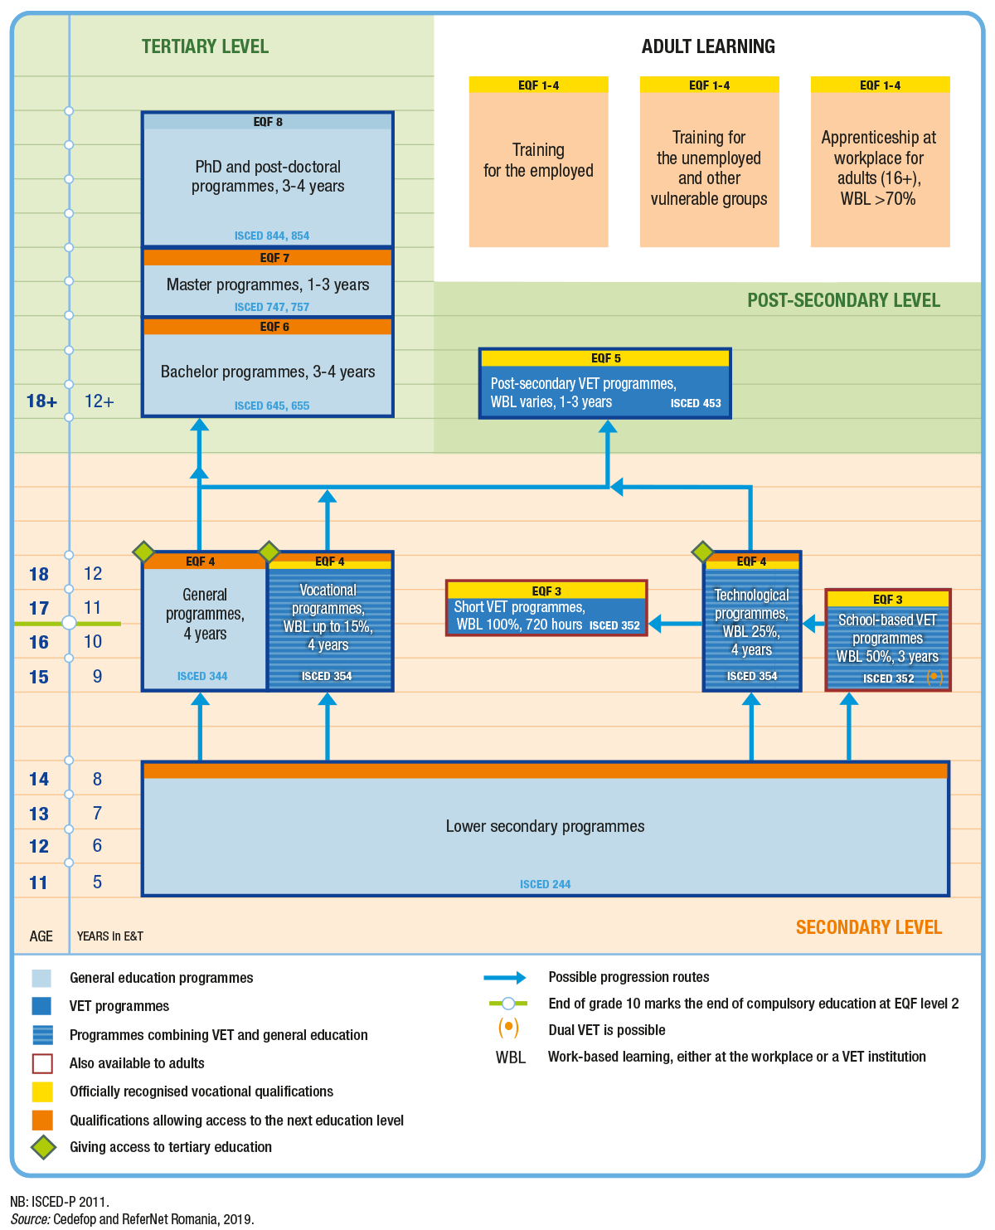
Figure 4:Romanian vocational education and training system chart.
Source: https://www.cedefop.europa.eu/en/tools/vet-in-europe/systems/romania-2019.

3.7 Greek Qualification Framework Reference
Vocational education and training in Greece is state-regulated and, until recently, was mainly offered school-based. After compulsory schooling, it is offered mainly at the upper secondary and post-secondary levels.
There are some distinctive features in the Greek learning process, such as that Greek society prioritizes general education and values university education highly. Participation rates in formal education are generally high; Greece has already achieved early school leaving goals.
Greek education and training system has eight NQF levels. The level of EQF-5 corresponds to Level 5 of the Greek Qualification Framework, more precisely consisting of:
- Vocational Upper Secondary School Degree, apprenticeship class
- Vocational Training Diploma (Initial Vocational Training / post-secondary level) after graduates’ certification
- Post-Secondary and not Higher Education Diploma or Degree.
Compulsory education in Greece lasts 11 years and extends from the ages of four to 15. The main stages of the Greek education system are primary, secondary, and tertiary education.
- Primary education includes pre-primary schools, infant/child centers, and primary schools.
- Secondary education that includes two cycles of study:
  - A lower secondary program, which is compulsory, lasts three years and provides general education and an evening lower secondary program.
  - Upper secondary programs, which are optional and can take the form of a general or vocational upper secondary program
- Tertiary education that comprises:
  - Universities
  - Polytechnics
  - School of fine arts
  - Technological education institutions
  - School of pedagogical and technological education (ASPETE).
The following vocational education and training system chart for Greece can be considered:

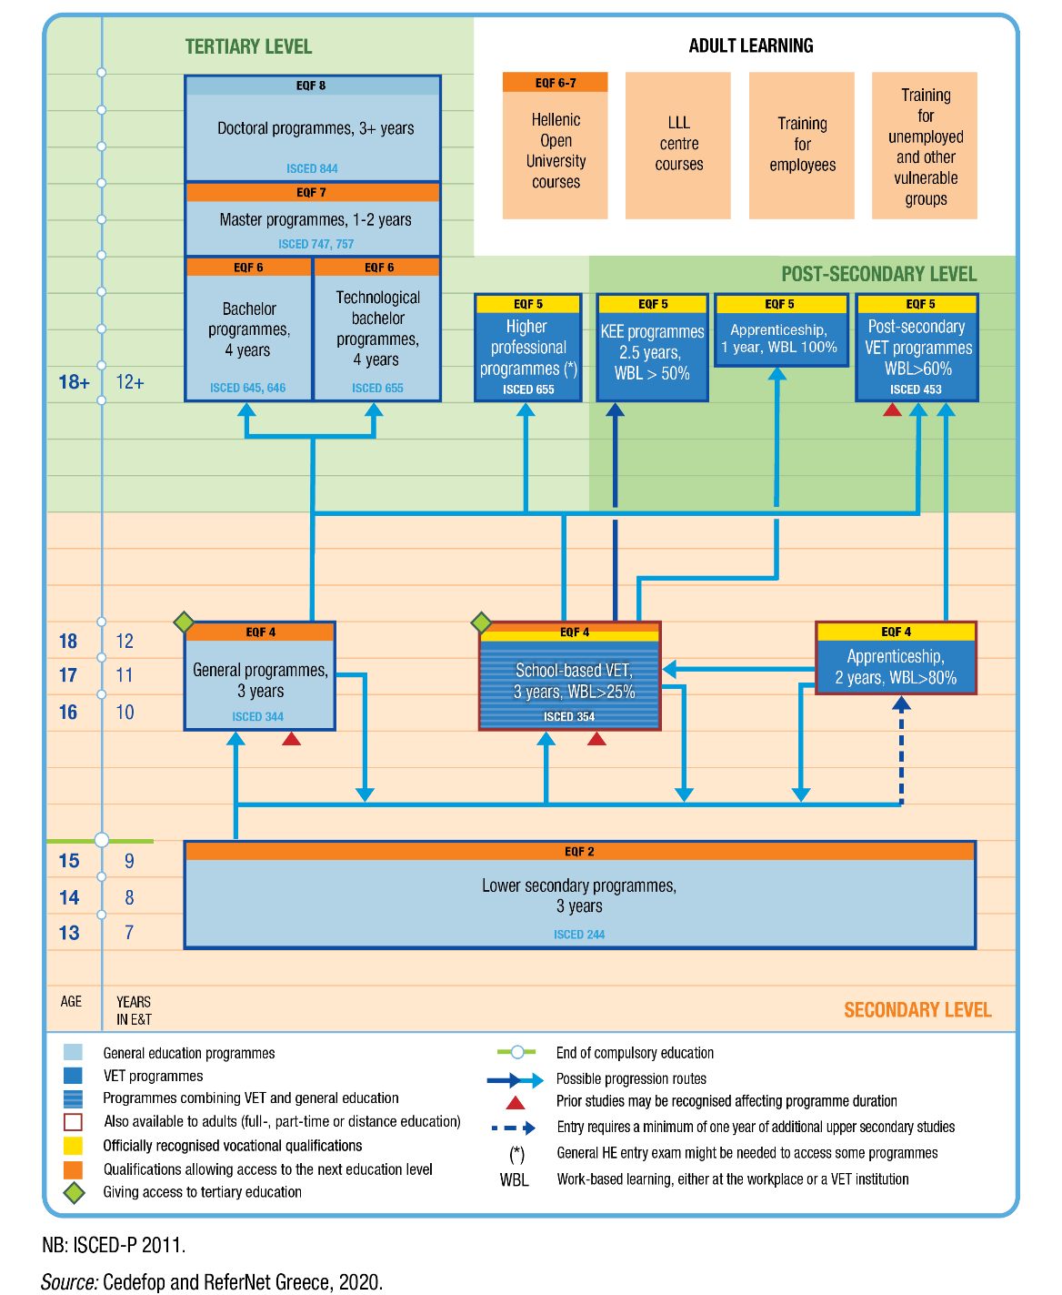
Figure 5: Greek vocational education and training system chart.
Source: https://www.cedefop.europa.eu/en/tools/vet-in-europe/systems/greece-2019.

4. Example of integrating learning units
This section presents an example of how to integrate MACHINA learning units into an existing curriculum. This curriculum has been modified for demonstration purposes to provide exemplary guidelines on how existing programs could integrate MACHINA learning outcomes and units.
This curriculum, addressed to ICT professionals, is currently being delivered by a VET provider in Nicosia, Cyprus. It is part of a master's program in computer science (MSc in computer science).

Table 1: Machine Learning and Data Mining course overview
Machine Learning and Data Mining course
Total hours of study | 1 semester approximately 300 hours
NQF level | 6+
ECTS credits | 10
Target audience | ICT professionals, computer science graduates
Course Objectives | Machine Learning is concerned with computer programs that automatically improve their performance through experience (e.g., programs that learn to identify fraudulent credit card transactions, recommend music and movies, categorize news articles based on the topic, etc). Data mining is the process of automatically discovering information from large data sets. This course covers the theory and practical algorithms for machine learning and data mining such as: classification, decision trees, Bayesian networks, neural networks, support vector machines, clustering. Emphasis will be given to recent applications of Machine Learning to Data Mining and text and web data processing.
Learning outcomes | After completion of the course students are expected to be able to:  - Demonstrate an understanding of the various machine learning algorithms used for classification and prediction.  - Analyse a machine learning problem and evaluate the likely effectiveness of different learning methods on that problem.  - Evaluate models/algorithms with respect their accuracy.  - Deal with data related issues that need to be addressed for successful data mining to be carried out.  - Implement a machine learning method and apply that method to a problem.  - Be familiar with cutting edge concepts and applications of machine learning and data mining like Deep Learning, Fraud Detection, Sentiment Analysis.
Prerequisites | Students are expected to have background knowledge in probability, linear algebra, statistics, and algorithms. Students with a strong numerate background should be able to catch up.
Table 2: Existing Curriculum Course Content
ID | Description | Duration  (in hours) | ECTS Credits
1 | Introduction to Machine Learning and Data Mining: Definitions, an overview of various topics, examples. | 30 | 1
2 | Data: Types of data, data preprocessing. | 30 | 1
3 | Classification: Basic Concepts. | 30 | 1
4 | Decision Tree Classifiers: How the tree works, building the decision tree, measures for selecting best split, algorithm for Decision Tree Induction. | 30 | 1
5 | Bayesian classifiers: using Bayes Theorem for classification, Naïve Bayes Classifier, Bayesian Networks. | 30 | 1
6 | Artificial Neural Networks (ANN): Perceptron, Multilayer ANN, Deep Learning. | 30 | 1
7 | Rule-based classifiers, nearest-neighbor classifiers, Support Vector Machines, Ensemble methods. | 30 | 1
8 | Evaluating Classifiers: Metrics, ROC curves, class imbalance problem. | 30 | 1
9 | Cluster Analysis: Basic concepts and algorithms (K-means, DBSCAN). | 30 | 1
10 | Data Mining Applications. | 30 | 1
Total |  | 300 | 10

4.1 Integration Phase 1: Prepare
The main findings drawn from research activities carried out in the context of the MACHINA project indicate that the most needed skills to work on machine learning applications and related services are mostly related to the following skills and knowledge:
- knowledge of mathematical and statistical models.
- Programming fundamental (Python, R, Apache, Spark, MapReduce, etc).
- Machine Learning Algorithms.
- Knowledge of deep learning.
- Knowledge of data structures and data modeling.
- Software engineering.
- Knowledge about preprocessing and cleaning of data.
- Business analytics.
- Communication.
As long as the curriculum under examination seeks to improve ICT professionals’ skills and knowledge in communication, business analytics, and software, integrating modules on software and communications will provide learners with a well-rounded skill set in this field.
Moving on from the above observation, there are two MACHINA units of learning outcomes that could be integrated into the existing curriculum.
- MACHINA Learning Unit 5 “Communication” will empower the participant to become an advanced communicator at the workplace. Each participant will learn the elements of communication and be able to flex each one to meet objectives.
- MACHINA Learning Unit 6, “Legislation, Ethics, Project Management related to ML,” introduces the EU ethical and legal regulations for ML applications. Identify the life cycle and project management requirements for an AI application.

4.2 Integration Phase 2: Design
Assuming that there is no constrain in terms of the duration of the new curriculum and none of the existing learning units need to be subtracted or replaced, there is no need to check interconnections of existing learning units due to prerequisites.
No other change in the new curriculum prerequisites is needed, as the minimum required experience of the existing curriculum is superior to the requirements for the MACHINA learning units (designed for learners with a minimal background). The addition of the new learning units requires the slight adaption of the credits weighting, considering the importance of each learning objective.
A logical sequence of the existing and the new learning units in the curriculum is indicated below.

Table 3: Learning units of updated curriculum
ID | Description | Duration  (in hours) | ECTS Credits
1 | Introduction to Machine Learning and Data Mining: Definitions, an overview of various topics, examples. | 30 | 1
2 | Data: Types of data, data preprocessing. | 30 | 1
3 | Classification: Basic Concepts. | 30 | 1
4 | Decision Tree Classifiers: How the tree works, building the decision tree, measures for selecting best split, algorithm for Decision Tree Induction. | 30 | 1
5 | Bayesian classifiers: using Bayes Theorem for classification, Naïve Bayes Classifier, Bayesian Networks. | 30 | 1
6 | Artificial Neural Networks (ANN): Perceptron, Multilayer ANN, Deep Learning. | 30 | 1
7 | Rule-based classifiers, nearest-neighbor classifiers, Support Vector Machines, Ensemble methods. | 30 | 1
8 | Evaluating Classifiers: Metrics, ROC curves, class imbalance problem. | 30 | 1
9 | Cluster Analysis: Basic concepts and algorithms (K-means, DBSCAN). | 30 | 1
10 | Data Mining Applications. | 30 | 1
11 | Communication | 30 | 1
12 | Legislation, Ethics, Project Management related to ML | 30 | 1
Total |  | 360 | 12

The “new curriculum” has been adapted to successfully integrate the two MACHINA learning units, based on their relative weight of the existing learning units in terms of the curriculum as a whole and considering the importance of their completion for achieving the learning objectives.
Finally, the existing curriculum has been attributed to an EQF 6, therefore since most of the MACHINA learning units have been attributed to EQF level 5, however since the additional learning units of the new curriculum are introductory and now form the basis of the course, the overall EQF level should not be altered.

Table 4: New Curriculum Description
Machine Learning and Data Mining course
Total hours of study | 360 hours
NQF level | 6+
ECTS credits | 12
Target audience | ICT professionals, computer science graduates
Course Objectives | Machine Learning is concerned with computer programs that automatically improve their performance through experience (e.g., programs that learn to identify fraudulent credit card transactions, recommend music and movies, categorize news articles based on the topic, etc). Data mining is the process of automatically discovering information from large data sets. This course covers the theory and practical algorithms for machine learning and data mining such as: classification, decision trees, Bayesian networks, neural networks, support vector machines, clustering. Emphasis will be given to recent applications of Machine Learning to Data Mining and text and web data processing.
Learning outcomes | After completion of the course students are expected to be able to:  - Demonstrate an understanding of the various machine learning algorithms used for classification and prediction.  - Analyse a machine learning problem and evaluate the likely effectiveness of different learning methods on that problem.  - Evaluate models/algorithms with respect their accuracy.  - Deal with data related issues that need to be addressed for successful data mining to be carried out.  - Implement a machine learning method and apply that method to a problem.  - Be familiar with cutting edge concepts and applications of machine learning and data mining like Deep Learning, Fraud Detection, Sentiment Analysis.  - Get familiar with basic communication principles and practices.  - Understand the components of effective communication and ways for using Machine Learning in Communications.  - Identify different types of application of ML in communication environments (eg. at the workplace)  - Understand the EU law and regulations for AI and ML applications.  - Identify the different type of bias in AI and their consequences.  - Know the project management requirement and lifecycle for AI applications.
Prerequisites | Students are expected to have background knowledge in probability, linear algebra, statistics, and algorithms. Students with a strong numerate background should be able to catch up.

5. MACHINA Project Certification

The MACHINA certificate is a document that provides additional information to that included in the official ICT vocational training certificates and transcripts, such as the skills, knowledges and competences acquired by learners and the work areas to which the program qualifies participants. It makes the official certificate more easily understood, especially by employers or institutions abroad.
The MACHIA project certificate will be issued to the ICT professionals who have successfully completed a VET course that incorporates the MACHINA learning outcomes. VET providers that have integrated part of MACHINA learning outcomes into their training offerings (as component of a broader ICT training program) are responsible of issuing the MACHINA certificates.

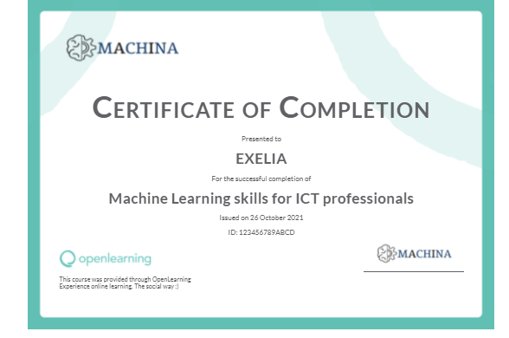
Figure 6: Example of a generated MACHINA project certification.

6. References
1- https://europa.eu/europass/en/description-eight-eqf-levels
3- https://www.cedefop.europa.eu/en/tools/vet-in-europe/systems/czechia-2019

